* **How to Import an Existing Project in Work Fusion:**

1. Open the work- Fusion Software. You can check technical manual to how to install and configure work-fusion.
2. 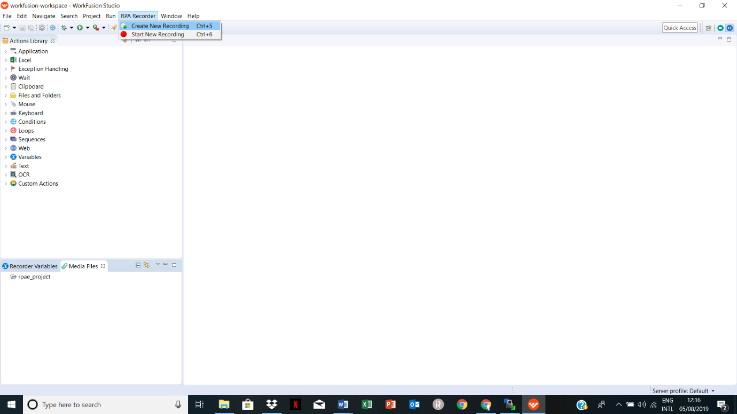Now create new recording in which you will be deploying your project. Give appropriate name to your recording.
3. After you create recording a new file will be created. Your new project will be created under rpae_project folder.

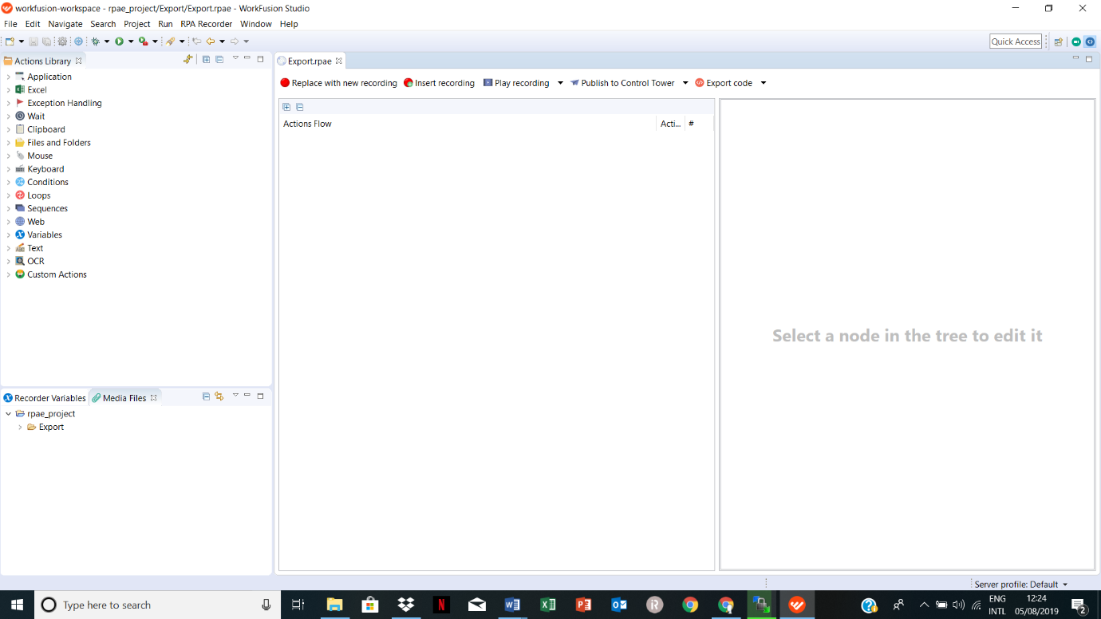

1. Right click on the export folder to import a new project. Then click on the import button.

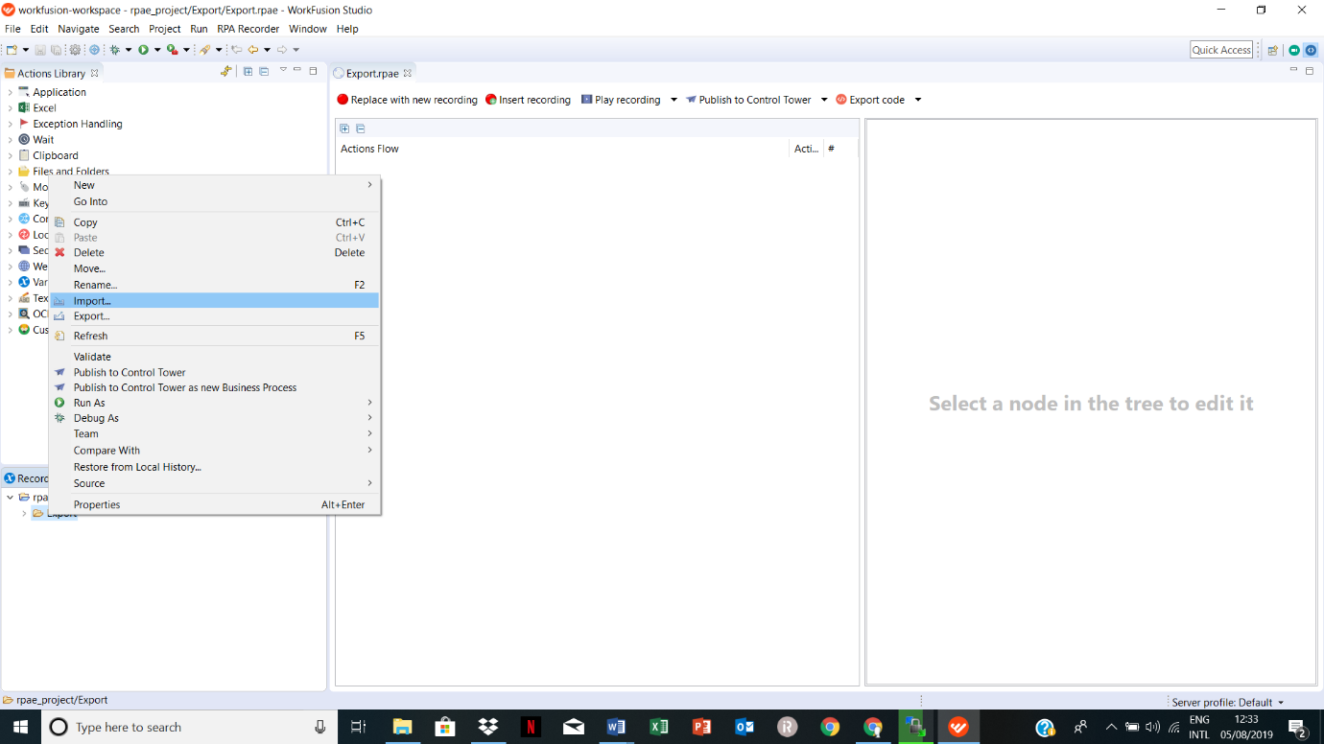

1. A new screen appears. Double click on the File system.

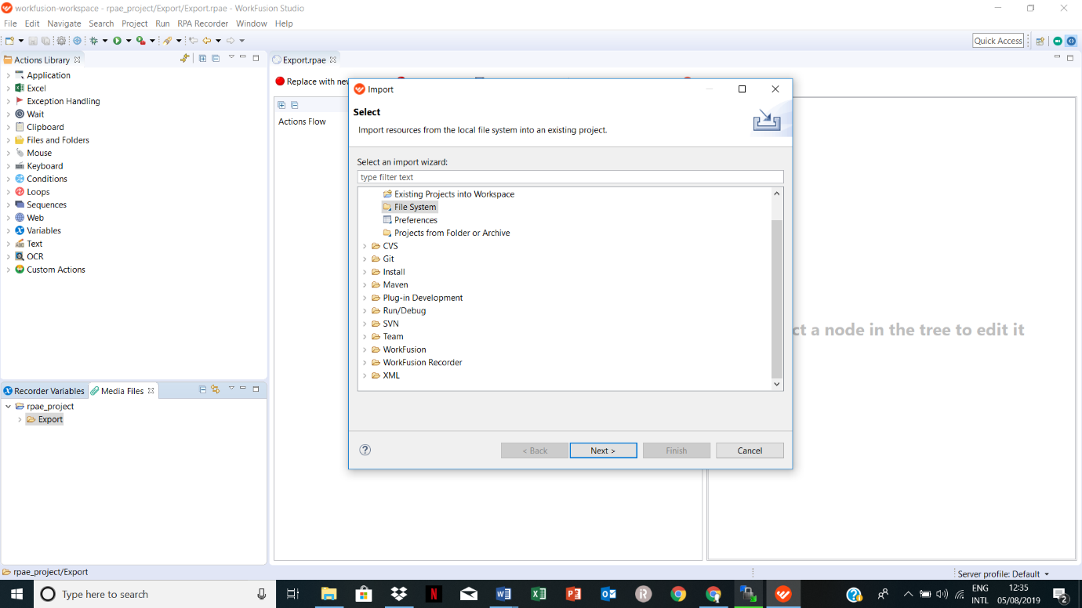

1. Now click on the browse option and select the path of your project. Once you select your project then click on option **select all**.

Then click on the finish to end up the process. Now your project is imported in your desired folder.

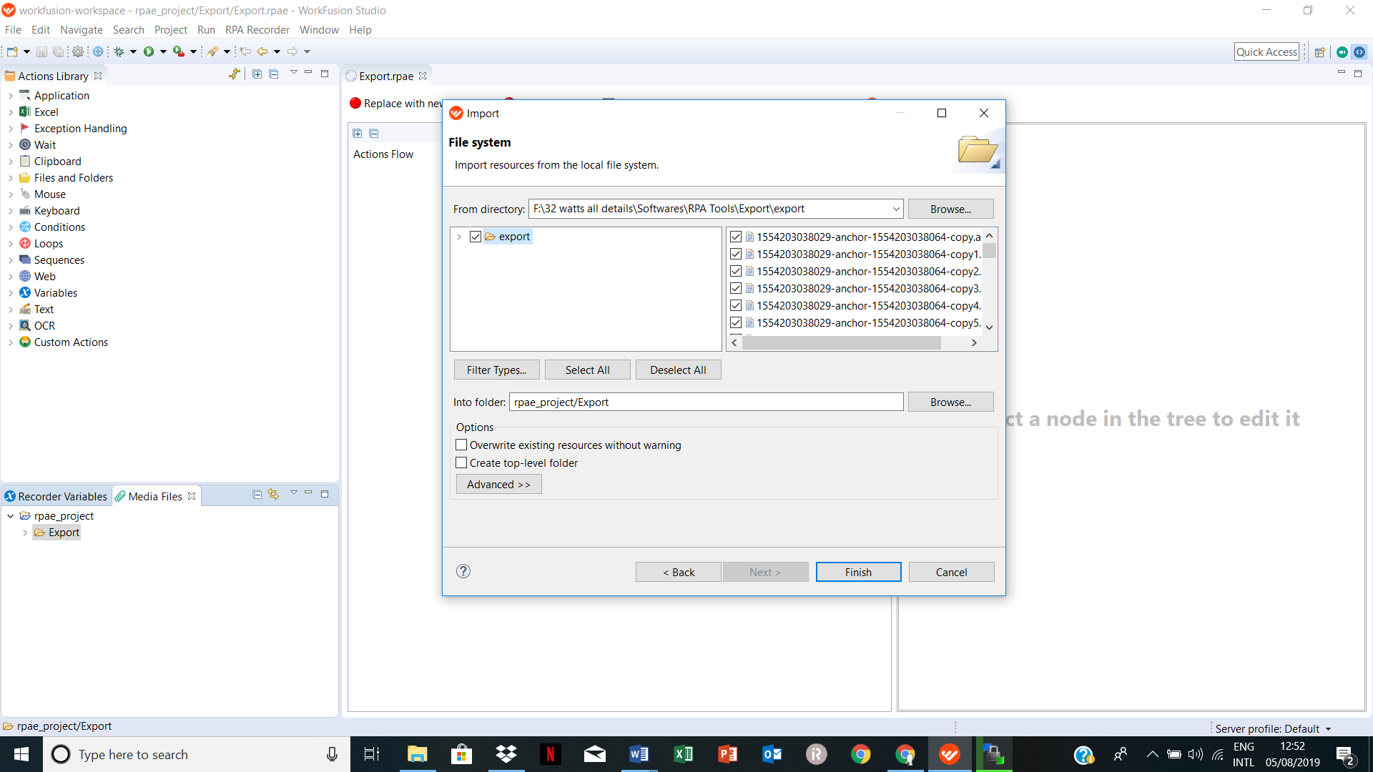

1. So u can check your project is imported successfully.

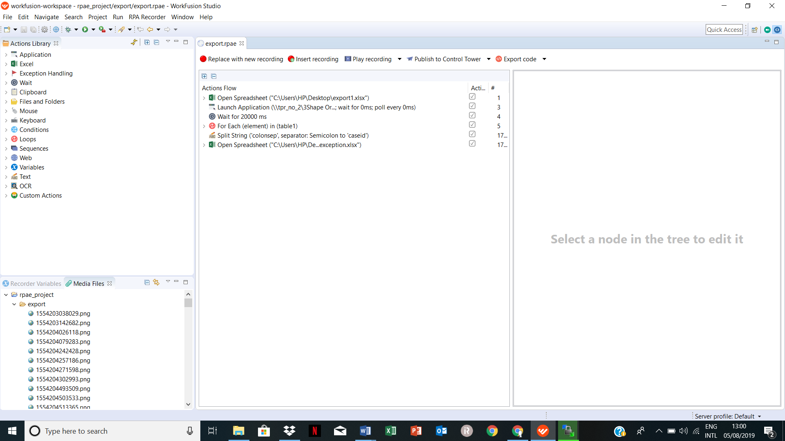

* **Prerequisite for export automation.**

1. The screen resolution must be 1980 X 1080. The automation will not work properly on other resolution screens.
2. The automation works fine on windows 10 operating system. All the automation projects are built on windows 10 only. For other system requirements you can check technical manual.
3. No need to turn off or uninstall antivirus during installation or any other process.
4. Export Automation works fine for a specific version of OrthAnalyzer. OrthoAnalyzer Orthodontics 2017 x64(build: 1.7.1.3 2018-2-23) is used in our automation process.

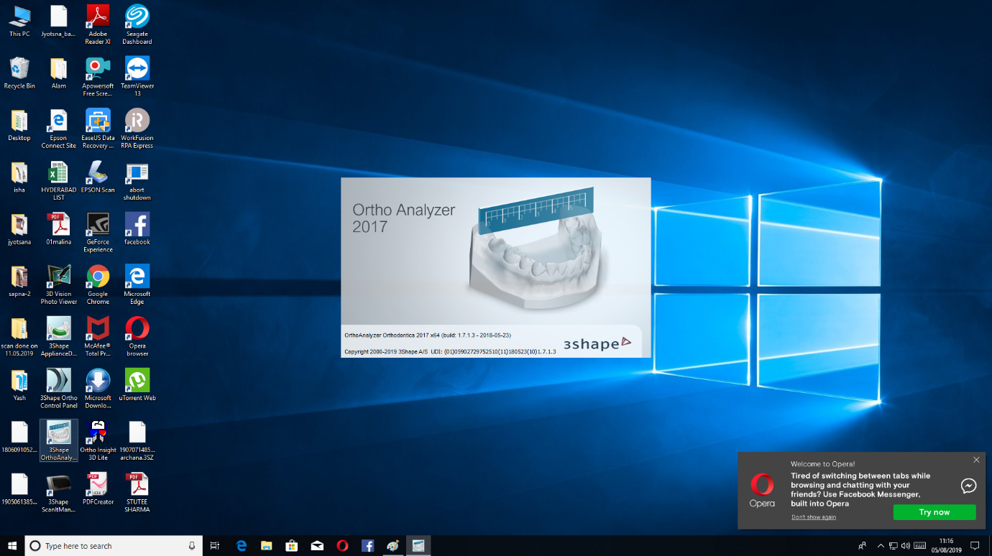

1. Note that all windows of orthoanalyzer must be opened in maximize mode. All Automation process is configured in maximize mode.
2. The export files are stored in orthodata2 automatically.

* **Prerequisite for Hollow Tag automation.**

1. The screen resolution must be 1980 X 1080. The automation will not work properly on other resolution screens.
2. The automation works fine on windows 10 operating system. All the automation projects are built on windows 10 only. For other system requirements you can check technical manual.
3. No need to turn off or uninstall antivirus during installation or any other process.
4. Export Automation works fine for a specific version of Appliance Designer. Appliance Designer Orthodontics 2017 x64( build: 1.7.1.3 2018-2-23) is used in our automation process.

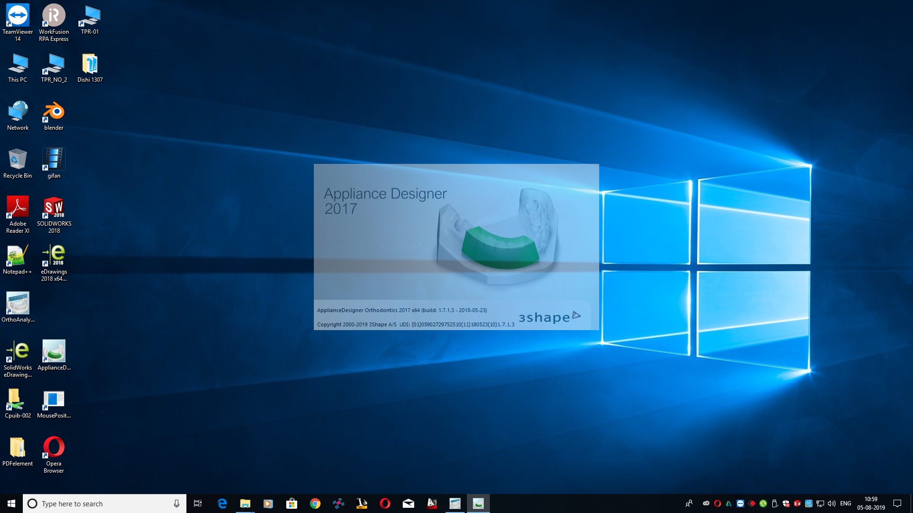

1. Note that all windows of orthoanalyzer must be opened in maximize mode. All Automation process is configured in maximize mode.
2. All the hollow tag files are saved in Hollow & Tag folder in E drive under patient’s case id folder. There is no need to create patient case id folder.

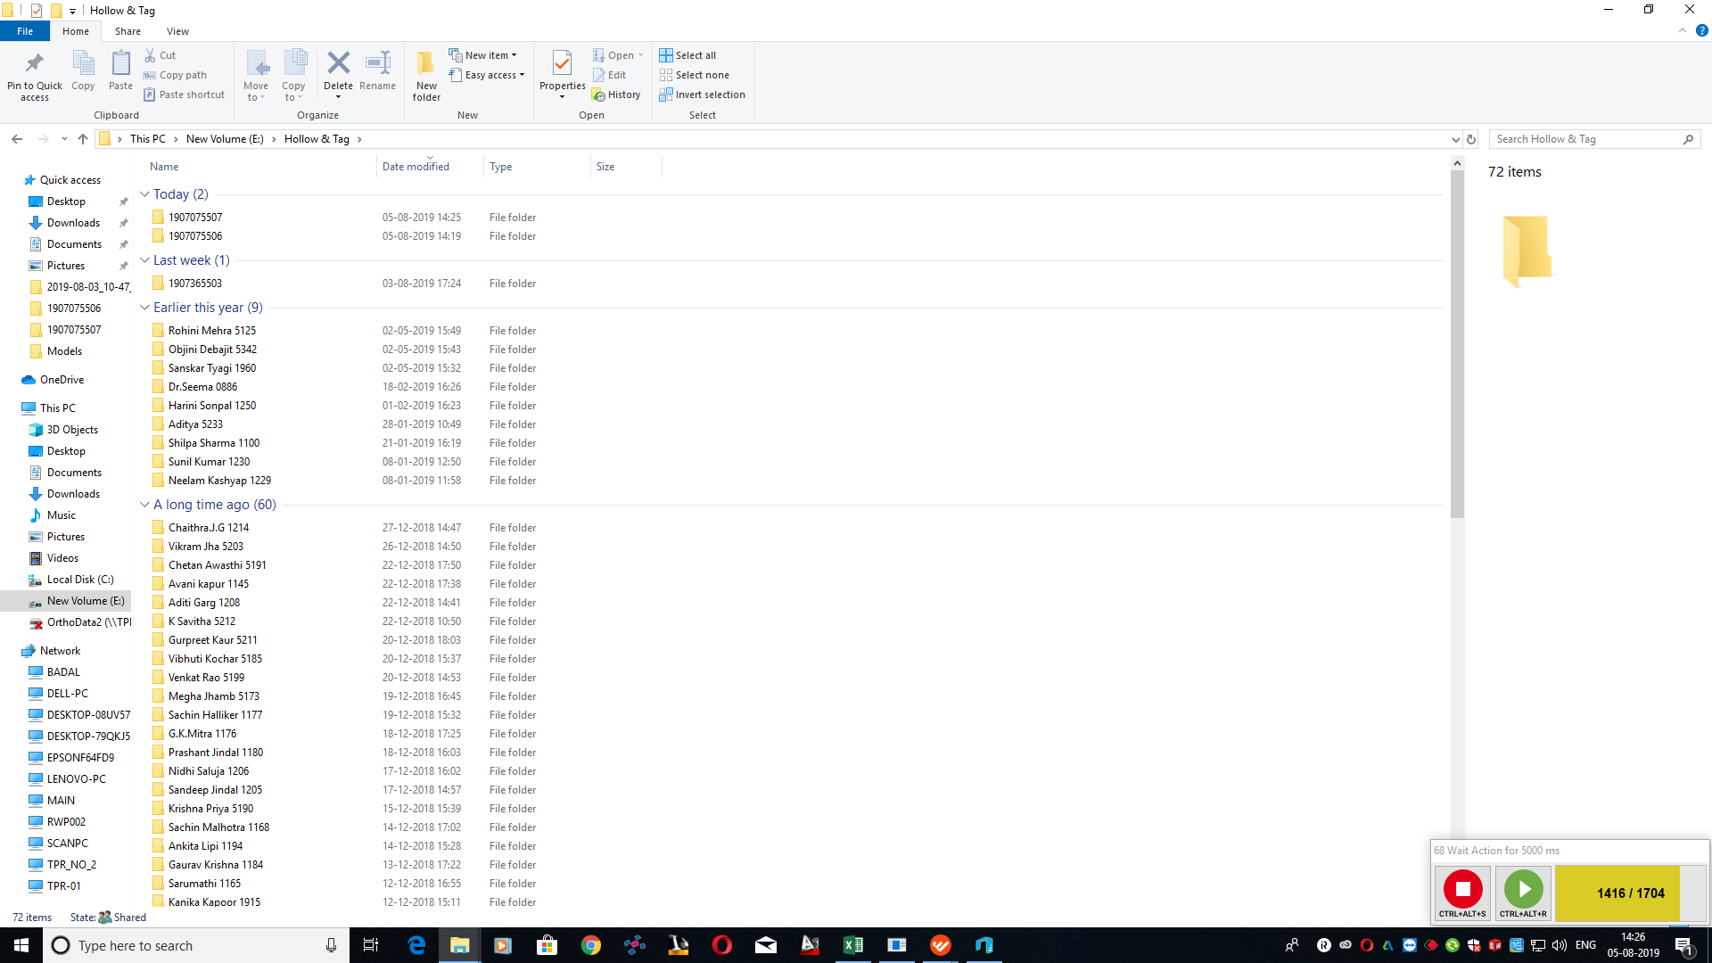

* **Prerequisite for 3D Builder automation.**

1. The screen resolution must be 1980 X 1080. The automation will not work properly on other resolution screens.
2. The automation works fine on windows 10 operating system. All the automation projects are built on windows 10 only. For other system requirements you can check technical manual.
3. No need to turn off or uninstall antivirus during installation or any other process.
4. 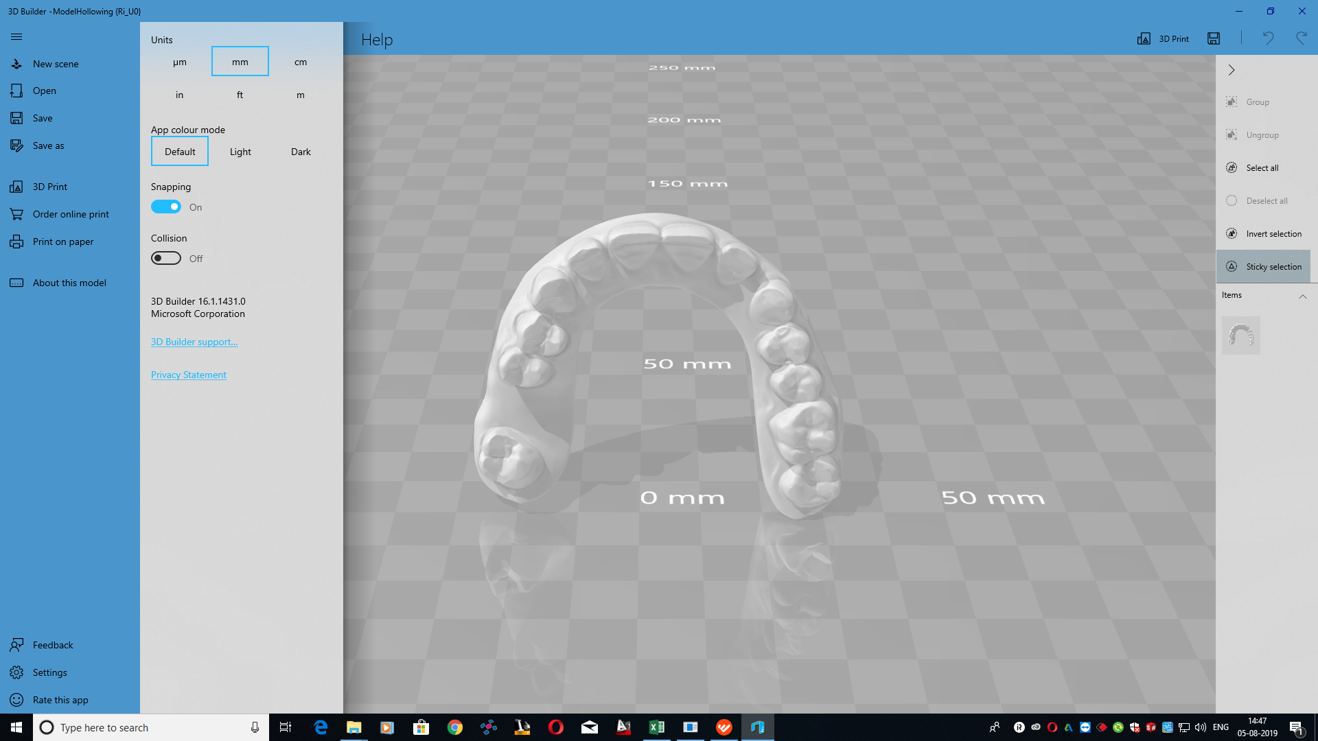Export Automation works fine for a specific version of 3D Builder. 3D Builder 16.1.1431.0 is used in our automation process.

* **Prerequisite for upload automation.**

1. The screen resolution must be 1600 X 900. The automation will not work properly on other resolution screens.
2. The automation works fine on windows 10 operating system. All the automation projects are built on windows 10 only. For other system requirements you can check technical manual.
3. No need to turn off or uninstall antivirus during installation or any other process.
4. Export Automation works fine for a specific version of OrthAnalyzer. OrthoAnalyzer Orthodontics 2017 x64( build: 1.7.1.3 2018-2-23) is used in our automation process.



1. Note that all windows of orthoanalyzer must be opened in maximize mode. All Automation process is configured in maximize mode.
2. The export files are stored in orthodata2 automatically.

* **Prerequisite for Gif animator automation.**

1. The screen resolution must be 1980 X 1080. The automation will not work properly on other resolution screens.
2. The automation works fine on windows 10 operating system. All the automation projects are built on windows 10 only. For other system requirements you can check technical manual.
3. No need to turn off or uninstall antivirus during installation or any other process.

Export Automation works fine for a specific version of Easy Gif animator. Easy GIF Animator Version 6.2 is used in our automation process.

* **Reference material for Work-Fusion.**

1. You can check some sort of videos present in company’s main computer.
2. You can go for work-fusion tutorial on YouTube.

<https://www.youtube.com/watch?v=78vTANopUDs&list=PLSjRhD23aSBo26dWVTfFfQRMMl85nF_fY>.

1. For more information, you can check forum blogs of RPA express.

<https://forum.workfusion.com/c/rpa-express>.